Seven Hills Restaurant

1896 Hyde St San Francisco, CA 94109

Website: <https://www.sevenhillssf.com/>





CUSTOMER REVIEW ANALYSIS

By Meghna Ghosh

Data Analytics Intern at CodEvo Solutions

Id: 592zr1wq

Date: 16/08/2024

CONTENTS

|  |  |  |
| --- | --- | --- |
| S. No | Content | Page no. |
| 1.  2.  3.  4.  5.  6.  7.  8. | About this Report  Methodology  Analytical Tools and Techniques  Visualization and Findings  Key Findings and Insights  Recommendations  Conclusion  Appendices | 3  4  5  6-7  8  9  10  11 |

ABOUT THIS REPORT

This report delves into the "Customer Review Analysis" of Seven Hills Restaurant, utilizing data meticulously gathered from Yelp, a renowned platform for customer feedback. The purpose of this analysis is to uncover key insights into customer sentiments, preferences, and areas for improvement, thereby providing actionable recommendations for the restaurant's management.

The data collection process began with sourcing a comprehensive set of customer reviews from Yelp. These reviews were then meticulously organized and cleaned using Microsoft Excel to ensure the data was accurate, relevant, and ready for detailed analysis. Following this, various analytical techniques were employed to structure the data, allowing for a clear representation of customer opinions and experiences.

To visualize the findings effectively, Power BI was utilized to create interactive dashboards and charts. These visual tools not only highlight critical patterns and trends within the customer feedback but also provide an intuitive way for stakeholders to engage with the data.

This report serves as a comprehensive document that encapsulates the entire process—from data collection and cleaning to analysis and visualization. It aims to provide the restaurant's management with a thorough understanding of their customer base and to support data-driven decision-making for enhanced customer satisfaction and business growth.

METHODOLOGY

Selection of Reviews:

* Time Frame: Reviews span different periods, capturing both recent and historical feedback.
* Diversity: Includes 1-5 star ratings for balanced insights.
* Geographic Variety: Reviews from various locations to understand diverse customer perceptions.

Data Extraction:

* Data Points: Collected review text, ratings, dates, and demographics using web scraping tools.
* Integrity: Verified accuracy by cross-referencing with Yelp.

Initial Data Assessment:

* Completeness & Accuracy: Checked for missing or incorrect entries and filtered relevant reviews.

Data Cleaning:

* Validation: Ensured consistency in key data fields.
* Handling Missing Data: Critical gaps were removed; non-critical gaps were imputed.
* Duplicate Removal: Identified and eliminated duplicates.

Text Preprocessing:

* Standardization: Cleaned and normalized text for analysis.
* Stemming & Lemmatization: Grouped similar words for coherence.

Data Structuring: Organized data into categories by rating, sentiment, and themes, then imported into Excel for analysis.

Analytical Tools and Techniques

Descriptive Statistics:

* Average Ratings & Distributions: Calculated in Excel to gauge customer satisfaction and identify rating trends.
* Review Trends over Time: Analyzed review counts to track changes in engagement or sentiment.
* Visualization: Key metrics were displayed through simple charts in Excel.

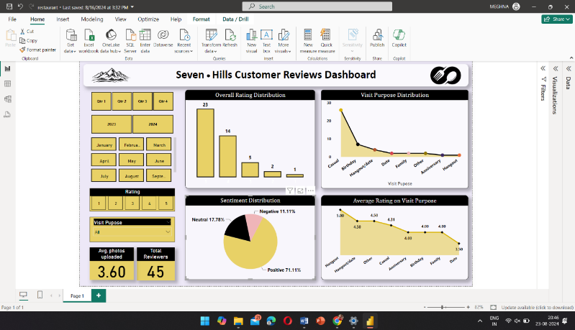Sentiment & Thematic Analysis:

* Sentiment Coding: Classified reviews as positive, negative, or neutral using both manual and NLP tools.
* Sentiment Scoring & Visualization: Scores were visualized in Power BI with pie charts and bar graphs.
* Thematic Analysis: Identified and clustered common themes like food or service quality, with frequency and sentiment visualized through word clouds and thematic charts in Power BI.

Power BI Visualization:

* Interactive Dashboards: Created to dynamically explore customer review data.
* Visual Elements & Filtering: Bar charts, pie charts, and line graphs with dynamic filtering allowed for detailed exploration.

Comparative Analysis:

Time & Demographic Segmentation: Compared sentiment and themes across different periods and customer demographics, visualized with side-by-side and stacked bar charts in Power BI.

Visualization and Findings

1. Overview of Power BI Dashboards

The Power BI dashboards provide an interactive exploration of the customer review data for Seven Hills Restaurant, focusing on key performance indicators (KPIs) like overall satisfaction, sentiment trends, and thematic analysis. Users can filter by date, rating, or sentiment to gain deeper insights into specific periods or customer segments. The dashboards feature visual elements like bar charts, pie charts, and word clouds to make trends and patterns easily identifiable.

2. Detailed Insights from Visualizations

Rating Distribution: Most reviews were 4 to 5 stars, indicating general satisfaction, with a noticeable portion of 1 to 2-star reviews highlighting areas for improvement.

Sentiment Trends: Sentiment varied over time, correlating with events like menu updates, providing insights into customer reactions to changes.

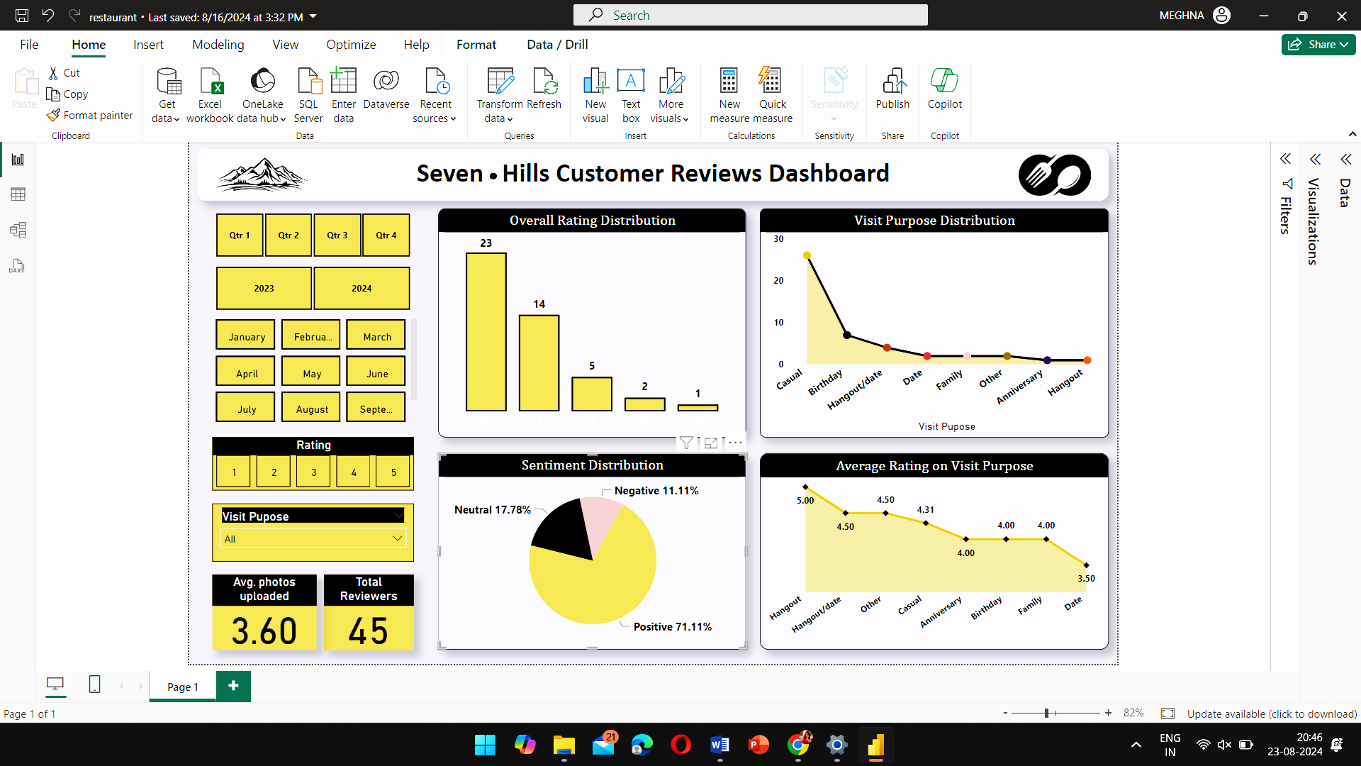Thematic Word Cloud: Key themes such as "service," "food," and "ambiance" were frequently mentioned, showing what customers valued most.

3. Analysis of Positive Feedback

High Ratings Correlation: Positive reviews often praised service, food quality, and ambiance, with repeat customers showing strong loyalty.

Favored Meals: Certain dishes consistently received high praise, helping identify popular menu items.

Recommendation Sources: Positive reviews often came from customers referred by friends or favorable online reviews, underscoring the importance of word-of-mouth.

4. Analysis of Negative Feedback

Common Complaints: Negative reviews frequently mentioned long wait times, inattentive staff, and issues with specific menu items.

Sentiment Analysis: Negative sentiment often pointed to broader operational issues rather than isolated incidents.

Impact of Visit Purpose: Special occasion diners had higher expectations, and unmet expectations led to more critical feedback.

5. Comparative Analysis by Customer Demographics

Local vs. Tourist Experiences: Locals provided more consistent feedback, while tourists were influenced by single-visit impressions.

Impact of Recommendation Source: Customers referred by friends had higher satisfaction due to positive expectations.

Visit Purpose and Satisfaction: Special occasion diners were more likely to leave detailed, impactful reviews.

Variation by Time of Visit: Weekend diners reported lower satisfaction due to busier conditions impacting service quality.

These insights were visualized through Power BI, using bar charts, line graphs, and heat maps, offering a clear, data-driven understanding of customer perceptions.

Key Findings and Insights

Strengths of Seven Hills Restaurant

* High-Quality Food: Customers consistently praised the taste, presentation, and quality of signature dishes, contributing to overall satisfaction.
* Ambiance: The welcoming and comfortable atmosphere was a key highlight, enhancing the dining experience.
* Friendly Staff: Personalized and attentive service was frequently commended, leading to positive customer experiences.
* Consistency for Regulars: Repeat customers appreciated the reliable food and service quality, indicating strong customer loyalty.

Areas for Improvement

* Service Efficiency: Issues with slow service during peak hours were noted, indicating a need for better management and scheduling.
* Menu Variety & Pricing: Customers suggested expanding menu options, especially for dietary preferences, and reassessing pricing for perceived value.
* Inconsistent Experiences: Some reviews highlighted occasional inconsistencies in food and service quality.
* Staff Training: Enhancing staff training, particularly in handling special requests and high-pressure situations, could improve customer satisfaction.

Emerging Trends and Patterns

* Healthy Options: There’s a growing demand for healthier, more nutritious menu items.
* Social Media Influence: Many customers discovered the restaurant through social media, emphasizing the importance of a strong online presence.
* Special Occasion Dining: The restaurant is often chosen for special events, underscoring the need for exceptional service during these times.
* Sustainability Concerns: A rising number of customers are interested in sustainability and ethical practices, such as sourcing local ingredients.

Recommendations

Enhancing Customer Service

* Service Efficiency: Increase staffing during peak hours and streamline operations to reduce wait times.
* Staff Training: Focus on customer interaction and handling high-pressure situations.
* Personalized Service: Use CRM tools to track preferences and offer tailored experiences.

Menu and Offerings

* Expand Variety: Introduce more dietary options and seasonal ingredients.
* Reassess Pricing: Adjust pricing for value and introduce promotions.
* Healthy Options: Add health-conscious dishes and provide nutritional info.

Operational Improvements

* Consistency: Implement stricter quality control and regular staff feedback sessions.
* Peak Time Management: Optimize reservations and table turnover.
* Feedback Loop: Systematize customer feedback collection and act on insights.

Long-term Growth

* Digital Presence: Boost social media engagement and manage online reviews.
* Special Occasions: Create event packages and target marketing efforts.
* Sustainability: Adopt eco-friendly practices and seek green certifications.
* Loyalty Programs: Launch a rewards program with exclusive perks for members.

Conclusion

Strengths:

* Quality Food & Ambiance: Consistently praised by customers, driving positive experiences and repeat visits.
* Attentive Staff: Noted for friendly, personalized service, enhancing overall satisfaction.

Areas for Improvement:

* Service Efficiency: Address wait times and service speed, especially during peak hours.
* Menu Variety & Pricing: Expand options and reassess pricing to attract a broader audience.
* Consistency: Strengthen quality control to maintain consistent food and service standards.

Emerging Trends:

* Health Consciousness: Increase health-conscious menu offerings to meet growing demand.
* Digital Influence: Leverage social media and online reviews for reputation management.

Strategic Focus

* Enhancements: Prioritize service improvements, menu refinement, and operational efficiency to elevate the dining experience.
* Long-term Growth: Strengthen digital presence, special occasion marketing, and sustainability efforts to support growth.
* Ongoing Improvement: Regularly monitor feedback to stay aligned with customer needs and drive continuous improvement.

APPENDICES

A: Data Collection

Yelp Data Extraction: Includes reviews with columns like date, reviewer name, rating, sentiment, and comments.

Sample Data: Example review highlighting data points such as rating, sentiment, and specific comments.

B: Data Cleaning & Preparation

Cleaning Process: Removed duplicates, handled missing values, standardized formats, categorized sentiments.

Preparation Steps: Normalized text, transformed categorical data, integrated data sources.

C: Analytical Tools & Techniques

Tools Used: Excel for cleaning, Power BI for dashboards.

Techniques: Descriptive stats, sentiment and thematic analysis, trend analysis.

D: Visualization Examples

Power BI Dashboards: Screenshots of key metrics and visualizations (e.g., ratings, sentiment, popular meals).

Charts: Rating distribution, sentiment breakdown, popular meals.

Sample Figures: Average ratings, sentiment by rating, favoured meals.

E: Customer Feedback

Selected Comments: Positive and negative excerpts.

Feedback Analysis: Recurring themes on service, food, and experience.